### NEW A146. Dis-Eur-Czech Republic-Moravia-Střelice-Bukovina-Figurine-Female-Venus-Ceramic

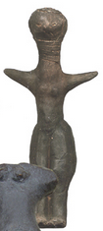

Fig. 1. Czech Republic-Moravia-Střelice-Bukovina-Figurine-Female-Venus-Ceramic

### **Formal Label:** Czech Republic-Moravia-Střelice-Bukovina-Figurine-Female-Venus-Ceramic

**Display Description:** Střelice Moravian ceramic figurines, such as this one, were located in the context of habitations (notably near hearths, see Sázelová 2008) in settled areas in large reoccupied sites near agricultural resources (Čižmář et alii 2008), which near this site is still being farmed today. This figurine has been sculpted in two volumes. The portion above the waist is apparently slender while the portion below the waist is more corpulent. This is a feature of many Střelice female figurines. This very conservative figural grammar (Humpolová and Podborský 2013) was evidently sustained for many generations based on C14 data (Kuča 2012, 2011). The head is unlike most Střelice female figurines in that the head has facial features and the hair is closely cropped. Since this figurine is not broken it may have been placed outside a habitation in a ritual area when the houses were ritually burned and the household was moved and figurines inside were ritually broken.

### **Accession Number:** A146

### LC Classification: GN772

**Date or Time Horizon:** 4,850 BCE-4,450 BCE

**Geographical Area:** Czech Republic, Moravia,Střelice-Bukovina

**Maps**, **GPS Coordinates:** 49.15694 16.50889;40° 26' 46" N 79° 58' 56" W

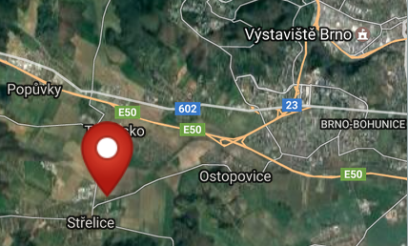 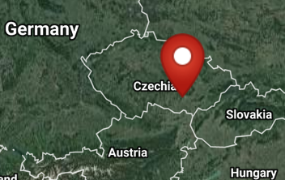

Figs. 2-3. Maps of Střelice-Bukovina from http://latitude.to/img/latitude-logo.svg

 

**Figs. 4-5. Photos of site:** after http://www.lands-of-venuses.eu/v-w-images/10-strelice/strelice-004a-bukovina-site.jpg

**Cultural Affiliation:** Neolithic

**Medium:** Fired clay.

**Dimensions: original, H** 22 cm (8.7 in).

**Weight:**

**Condition: museum replica in resin.**

**Provenance:** Czech Republic, Moravia,Střelice Museum.

**Discussion:**

Since this figurine is slender above the waist and more corpulent below the waist suggests that this figurine is associated with a general social and health anxiety for safe childbirth. Figurines incorporating indications of these anxieties may have accompanied the instructions (perhaps incorporated in rituals) by women midwives who had expertise in the care of pregnant mothers and the practice and art of delivering babies safely.In Neolithic communities it was important to have many children as the agricultural work required many hands. Midwives still perform the same tasks to assist their communal sisters in pregnancy and childbirth. Indeed, a similar anxiety to have many children is noticeable today among traditional farming families in many parts of the world, especially in Africa, India, and South America.

**References:**

Čižmář, Zdeněk, ed*.* 2008. *Život a smrt v mladší době kamenné. Katalog výstavy. Leben und Tod in der Jungsteinzeit.* [Life and Death in the New Stone Age.] Brno:Ústav archeologické památkové péče ve spolupráci s Jihomoravskzm muzeem ve Znojmě a Moravským zemským muzeem v Brně.

Humpolová, Alena and Vladimír Podborský. 2013. *To nejlepší z archeologické sbírky Františka Vildomce.* [The Best of the Archaeological Collection of František Vildomec]. Brno: Moravské zemské muzeum.

Králík, Miroslav and Novotný, Vladimír. 2005. Dermatoglyphics of Ancient Ceramics. In: Svoboda Jiří, ed. *Pavlov I Southeast. A Window into the Gravettian Lifestyles*. Brno: Academy of Sciences of the Czech Republic, Institute of Archaeology, and Kraków: Polish Academy of Sciences, Institute of Systematics and Evolution of Animals, Chapter IV.5, pp. 449-430.

Kuča, Martin, Jan Josef Kovář, Miriam Nývltová Fišáková, Petr Škrdla, Lubomír Prokeš, Miroslav Vaškových, and Zdeněk Schenk. Chronologie neolitu na Moravě. Předběžné výsledky. 2012. [Chronology of the Moravian Neolithic. Preliminary results.] Přehled výzkumů, 53(1).

Kuča, Martin, Jan Josef Kovář, Miriam Nývltová Fišáková, Petr Škrdla, Lubomír Prokeš, Miroslav Vaškových, and Zdeněk Schenk. 2011. Chronologie neolitu na Moravě: Předběžné výsledky,” *Přehled výzkumů*, 53(1).

Sázelová, Sandra. 2008. “Female Figurines of Northern Eurasia: An Ethnological Approach.” In Svoboda, Jiří A., *Petřkovice. On Shouldered Points and Female Figurines.* The Dolní Věstonice Studies, Vol. 15, Brno: Academy of Sciences of the Czech Republic, Institute of Archaeology, pp. 224-232.

Svoboda, Jiri, Vojen Lozek, and Emanuel Vlcek. 1996. *Hunters between East and West, the Paleolithic of Moravia*. New York: Plenum Press; New York: Springer.